
DATASTRUCTURES AND ALGORITHMS
23CSE203
LAB MANUAL
SUBMITTED BY
NAME | PAVANA HAASINI LATTALA
ROLL NO | AV.SC.U4CSE25033
YEAR/SEM/SECTION | 2ND YEAR/SEM-3/CSE-A
CREDITS | 03

SUBMITTED TO
NAME | DR. RAJ KUMAR BATCHU
DEPARTMENT | SCHOOL OF COMPUTING
DESIGNATION | ASST. PROFESSOR (SL GRADE)
INDEX
S.NO | TITLE | Pg.No | REMARKS
1. | WEEK1:1. Recursive countdown from n to Launch.  2. Recursive calculation of compound growth factor.  3. Recursive search for employee ID in list.  4. Recursive factorial calculation for parcel arrangements.  5. Recursive Fibonacci series generation. | 5-13
2. | WEEK 2: 1) write a python program to perform linear search on the given input.  2.a)write a python program to perform binary search on the given input verify by taking sorted array.  2.b) write a python program to perform binary search on the given input verify by taking unsorted array. | 14-20
3. | WEEK 3: a) Write a python program to sort the elements using bubble sort technique. Take an input from the user.  b) Write a python program to sort the elements using insertion sort technique. Take an input from the user.  c) Write a python program to sort the elements using selection sort technique. Take an input from the user.  d) Write a python program to sort the elements using quick sort technique. Take an input from the user.  e) Write a python program to sort the elements using merge sort technique. Take an input from the user. | 21-32
 | WEEK-4: 4a). Write the python program to implement a single linked list which could perform the below operations,by taking an input from the user.  4b). Write the python program to implement a double linked list which could perform the below operations,by taking an input from the user.  4c). Write the python program to implement a circular linked list which could perform the below operations,by taking an input from the user. | 33-80
 | WEEK-5: Write a python program to implement a stack using an Array, Linked list. Implement the stack operations such as push, pop, peak and also display the stack elements. | 81-92

LAB-1
1)AIM: A rocket launch system displays a countdown before launch. Instead of using a loop implement the countdown using recursion .write a recursion python program to display a countdown from n to 1 followed by “launch”.
PROGRAM:
def launch(n):
for i in range(n,-1,-1):
if i==0:
print("launch")
else:
print(i)
n=int(input("Enter no. of seconds to launch:"))
launch(n)

OUTPUT:
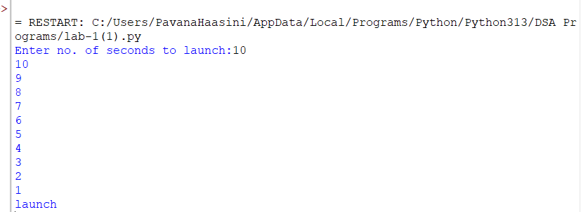

EXPLANATION:
This program displays a countdown from n to 1 and finally prints 'launch'. Although the aim mentions recursion, the given code uses a loop.
ERROR TABLE:
ERROR | CAUSE | SOLUTION
Indentation Error | Statements are not properly indented inside the function. | Indent the for loop and if-else block correctly.
Invalid input | User may enter a non-integer value. | Enter only an integer for the number of seconds
Wrong function call | Launch(n) may be placed before taking input. | Take input first, then call launch(n).

2)AIM: Banks calculate the growth of an investment using compound interest the formula requires calculating powers. Which can be implemented recursively. Write a recursive program to calculate p^n(power),where p=principal growth factor, n= number of years.
PROGRAM:
def interest(p,n):
if n==0:
return 1
else:
return p*interest(p,n-1)
n=int(input("Enter no.of years:"))
p=int(input("Enter a number:"))
res=interest(p,n)
print(res)

OUTPUT:
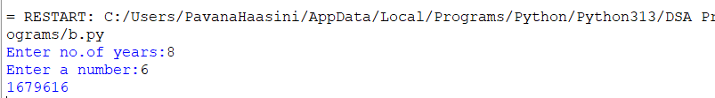
EXPLANATION:
This program recursively calculates p^n by multiplying p until n becomes 0.
ERROR TABLE:
ERROR | CAUSE | SOLUTION
Recursion error | Negative value of n never reaches the base condition | Allow only n >= 0
Value error | User enters a non-integer value | Enter an integer for years and principal
Wrong result | The function calculates pⁿ, not normal simple interest | Use the correct interest formula if simple interest is required

3)AIM: An HR department stores employee ID’s in a list. Develop a recursive program to search for a given employee ID .write a recursive function to search for an employee ID in a list.
PROGRAM:
def search(m):
key=m
for i in range(n-1):
if arr[i]==key:
return i
n=int(input("enter no.of employees to add:"))
arr=[]
for i in range(n):
a=int(input("enter a value:"))
arr.append(a)
print(arr)
m=int(input("enter a element to search:"))
result=search(m)
if result==-1:
print("element is not found")
else:
print("employee id is stored at the index:",result)

OUTPUT:
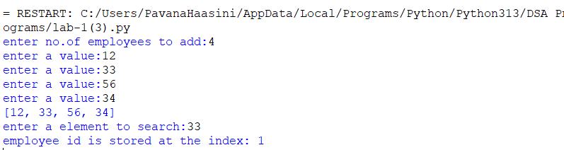
EXPLANATION:
This program searches for an employee ID in a list and returns its index if found.
ERROR TABLE:
ERROR | CAUSE | SOLUTION
Last element not searched | range(n-1) stops before the last index | Use range(n)
Wrong result when element is absent | Function does not return -1 | Add return -1 after the loop
Name error | n is used inside search() as a global variable | Use len(arr) inside the function

4)AIM: In a logistics company the number of possible ways to arrange n different parcels is calculated using the factorial formula(n!). develop a recursive program to calculate the factorial of a given number.
PROGRAM:
def fact(n):
fact=1
for i in range(1,n+1):
fact=fact*i

return fact
n=int(input("enter a number to find its factorial:"))
result=fact(n)
print(result)

OUTPUT:
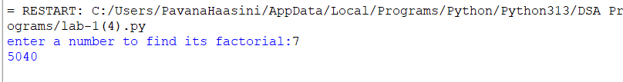
EXPLANATION:
This program calculates the factorial of a number using iteration (not recursion).
ERROR TABLE:
ERROR | CAUSE | SOLUTION
Indentation error | return fact is incorrectly indented | Keep return fact inside the function and outside the loop
Invalid factorial | Negative number is entered | Check if n < 0 and display an error
Value error | User enters a non-integer value | Enter an integer

5)AIM: Write a recursive python program to print the first n terms of the Fibonacci series.
PROGRAM:
def fib(n):
if n==0:
return 0
elif n==1:
return 1
else:
return fib(n-1)+fib(n-2)

n=int(input("enter no of terms:"))
if n<=-1:
print("invalid input")
else:
for i in range(n):
print(fib(i),end=" ")

OUTPUT:
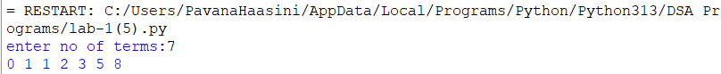

EXPLANATION:
The program uses recursion to generate Fibonacci numbers. fib (0)=0 and fib (1) =1 are the base cases. For every other term, fib(n)=fib(n-1) + fib(n-2). The loop prints the first n terms.

ERROR TABLE:

ERROR | CAUSE | SOLUTION
Invalid input | User enters a negative number | Check if n < 0
Recursion error | Incorrect base condition can cause infinite recursion | Keep base cases n == 0 and n == 1
Value error | User enters a non-integer value | Enter an integer for number of terms

LAB-2
2a)AIM: Write a program to perform linear search on a given input.

PROGRAM:
def linear_Search(arr, key):
for i in range(len(arr)):
if arr[i] == key:
return i
return -1
n=int(input("Enter no. of elements:"))
arr=[]
print("Enter Elements:")
for i in range(n):
arr.append(int(input()))
key = int(input("Enter the elements to search:"))
result= linear_Search (arr,key)

if result!=-1:
print("Enter found at index",result)
else:
print("Element not found")

OUTPUT:
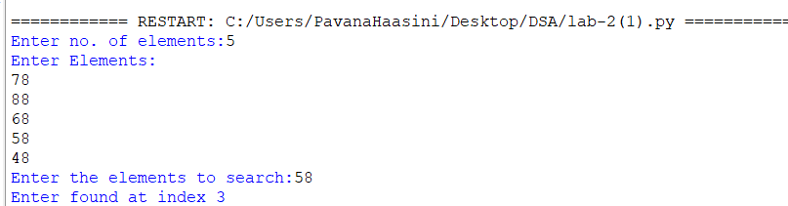EXPLANATION:
This program performs Linear Search to find an element in a list.
It takes the number of elements and their values from the user.
The linear_Search() function checks each element one by one and returns its index if found.
If the element is not found, it returns -1 and displays "Element not found."

ERROR TABLE:
ERROR | CAUSE | SOLUTION
Enter found at index | Typing mistake in the print statement | Change it to Element found at index
linear_Search (arr,key) | Extra space before ( is unnecessary and can make the code look inconsistent | Write linear_Search(arr, key)
Enter the elements to search: | "elements" is plural even though only one search value is entered | Change it to Enter the element to search:

2b)AIM: Write a Python program to perform binary search on the given input.
A) SORTED ARRAY:
PROGRAM:
def binary_Search(arr, key):
low = 0
high = len(arr) - 1
while low <= high:
mid = (low + high) // 2
if arr[mid] == key:
return mid
elif arr[mid] < key:
low = mid + 1
else:
high = mid - 1

return -1
n = int(input("Enter no. of elements: "))
arr = []
print("Enter Elements:")
for i in range(n):
arr.append(int(input()))

key = int(input("Enter the element to search: "))
if arr != sorted(arr):
print("Array is unsorted. Binary search cannot be performed.")
else:
result = binary_Search(arr, key)
if result != -1:
print("Element found at index", result)
else:
print("Element not found")
OUTPUT:
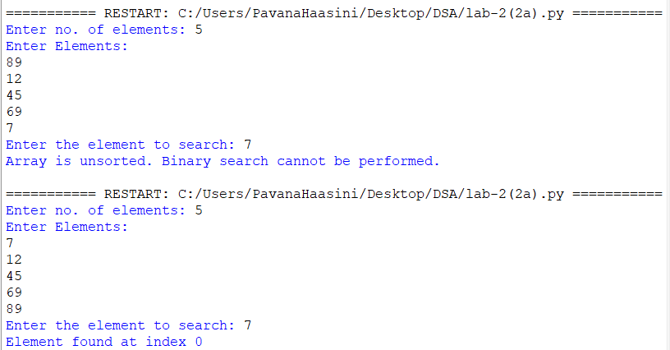B) UNSORTED ARRAY:
PROGRAM:
def binary_Search(arr, key):
low = 0
high = len(arr) - 1
while low <= high:
mid = (low + high) // 2
if arr[mid] == key:
return mid
elif arr[mid] < key:
low = mid + 1
else:
high = mid - 1

return -1
n = int(input("Enter no. of elements: "))
arr = []
print("Enter Elements:")
for i in range(n):
arr.append(int(input()))

key = int(input("Enter the element to search: "))
if arr == sorted(arr):
print("Array is sorted.")
else:
print("Array is unsorted.")
arr.sort()
print("Sorted array:", arr)
result = binary_Search(arr, key)
if result != -1:
print("Element found at index", result)
else:
print("Element not found")
OUTPUT:
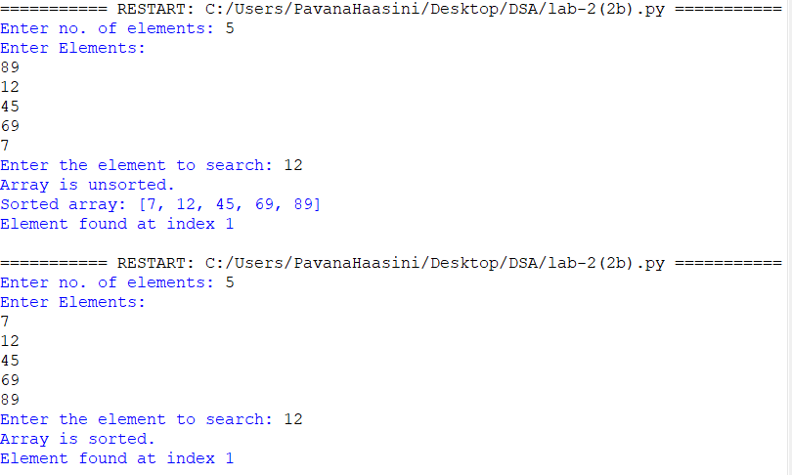EXPLANATION:
This program performs Binary Search on a given array.
It checks whether the array is sorted; if it is unsorted, the program sorts it before performing the search.
The binary_Search() function repeatedly divides the array into two halves to find the required element.
Finally, it displays the index of the element if found, otherwise it displays "Element not found."

ERROR TABLE:
ERROR | CAUSE | SOLUTION
Binary search on an unsorted array | Binary search requires a sorted array | Check the array and sort it using arr.sort()
Incorrect middle index | Wrong calculation of mid | Use mid = (low + high) // 2
Wrong search range | low and high are not updated correctly | Use low = mid + 1 or high = mid - 1
Element not found condition missing | Result -1 is not checked | Use if result != -1
Wrong index displayed | Confusing index with position | Use result + 1 if displaying the position
Searching before sorting | Binary search is performed before arranging an unsorted array | Sort the array before calling binary_Search()

LAB-3
3a)AIM: Write a Python program to perform Bubble Sort on the given input.
PROGRAM:
def bubble_sort(arr):
n = len(arr)

for i in range(n):
for j in range(0, n - i - 1):
if arr[j] > arr[j + 1]:

arr[j], arr[j + 1] = arr[j + 1], arr[j]
n = int(input("Enter no. of elements: "))
arr = []

print("Enter the elements:")
for i in range(n):
arr.append(int(input()))
bubble_sort(arr)
print("Sorted array:")
for element in arr:
print(element, end=" ")
OUTPUT:
EXPLANATION:
This program uses Bubble Sort to arrange the elements of an array in ascending order.
It repeatedly compares two neighboring elements and swaps them if they are in the wrong order.
The program takes the number of elements and their values from the user, sorts them, and displays the sorted array.
ERROR TABLE:
ERROR | CAUSE | SOLUTION
IndentationError | Incorrect indentation inside the for loop or if statement. | Maintain proper Python indentation.
ValueError | User enters a non-integer value when int(input()) is used. | Enter only valid integer values.
IndexError | Incorrect loop range may cause access beyond the array boundary. | Use range(0, n - i - 1) as shown in the program.

3b)AIM: Write a Python program to perform Insertion Sort on the given input.
PROGRAM:
def Insertion_sort(arr):
n=len(arr)
for i in range(1,n):
key=arr[i]
j=i-1

while j>=0 and arr[j]>key:
arr[j+1]=arr[j]
j-=1
arr[j+1]=key
return arr

n=int(input("Enter no. of Elements:"))
arr=[]
print("Enter Elements:")

for i in range(n):
arr.append(int(input()))

Insertion_sort(arr)
print("Sorted array:")
for element in arr:
print(element, end=" ")
OUTPUT:
EXPLANATION:
The program first takes the number of elements and stores them in the array arr.
The Insertion_sort() function selects each element as key and compares it with the elements before it.
Larger elements are shifted one position to the right, and the key is placed in its correct position.
Finally, the program prints the elements of the array in ascending order.
ERROR TABLE:
ERROR | CAUSE | SOLUTION
TypeError | Comparing incompatible data types, such as a string and an integer. | Convert input values using int(input()).
NameError | Using a variable that has not been defined or using the wrong variable name. | Check and use the correct variable names.
SyntaxError | Missing symbols such as : or brackets in the code. | Check the syntax and add the required symbols.

3c)AIM: Write a Python program to perform Selection Sort on the given input.
PROGRAM:
def Selection_sort(arr):
n=len(arr)
for i in range(n-1):
min_index=i
for j in range(i+1,n):
if arr[j]<arr[min_index]:
min_index=j
arr[i],arr[min_index] = arr[min_index],arr[i]
return arr

n=int(input("Enter no. of Elements:"))
arr =[]
print("Enter Elements:")
for i in range (n):
arr.append(int(input()))
Selection_sort(arr)

print("Sorted array:", arr)
for element in arr:
print(element,end=" ")
OUTPUT:
EXPLANATION:
The program first reads the number of elements and stores them in the array arr.
The Selection_sort() function finds the smallest element in the unsorted part of the array.
It then swaps the smallest element with the first element of the unsorted part and repeats this process.
Finally, the program prints the array in ascending order.
ERROR TABLE:
ERROR | CAUSE | SOLUTION
ValueError | Entering a value that cannot be converted into an integer. | Enter only valid integer values.
IndexError | Trying to access an array position that is outside its valid range. | Make sure the loop ranges stay within the array length.
UnboundLocalError | Using a local variable before assigning a value to it. | Initialize the variable before using it.

3d)AIM: Write a Python program to perform Merge Sort on the given input.
PROGRAM:
def merge_sort(arr):
if len(arr)<=1:
return arr

mid=len(arr)//2
left=arr[:mid]
right=arr[mid:]

merge_sort(left)
merge_sort(right)
i=j=k=0
while i<len(left) and j<len(right):
if left[i]<=right[j]:
arr[k]=left[i]
i+=1
else:
arr[k]=right[j]
j+=1
k+=1
while i<len(left):
arr[k]=left[i]
i+=1
k+=1
while j<len(right):
arr[k]=right[j]
j+=1
k+=1

n=int(input("Enter no. of elements:"))
arr=[]
print("Enter Elements:")
for i in range (n):
arr.append(int(input()))
merge_sort(arr)
print("Sorted array:")
for element in arr:
print(element,end=" ")
OUTPUT:
EXPLANATION:
The program uses Merge Sort to arrange the elements of the array in ascending order.
The merge_sort() function divides the array into two smaller parts repeatedly until each part contains one element.
It then compares and merges the smaller parts in the correct order to form the sorted array.
Finally, the program prints all the elements of the sorted array.
ERROR TABLE:
ERROR | CAUSE | SOLUTION
RecursionError | The function keeps calling itself without reaching the stopping condition. | Make sure the base condition if len(arr) <= 1 is present.
AttributeError | Trying to use an array operation on an inappropriate data type. | Make sure arr is a list before passing it to merge_sort().
UnboundLocalError | A local variable such as i, j, or k is used before being initialized. | Initialize the variables before the while loops.
3e)AIM: Write a Python program to perform Quick Sort on the given input.
PROGRAM:
def quick_sort(arr, low, high):
if low < high:
pivot = arr[high]
i = low - 1

for j in range(low, high):
if arr[j] <= pivot:
i += 1
arr[i], arr[j] = arr[j], arr[i]

arr[i + 1], arr[high] = arr[high], arr[i + 1]
p = i + 1
quick_sort(arr, low, p - 1)
quick_sort(arr, p + 1, high)
n = int(input("Enter no. of elements: "))
arr = []

print("Enter the elements:")
for i in range(n):
arr.append(int(input()))

quick_sort(arr, 0, n - 1)

print("Sorted array:")
for element in arr:
print(element, end=" ")
OUTPUT:
EXPLANATION:
The program uses Quick Sort to arrange the elements of the array in ascending order.
The quick_sort() function selects the last element as the pivot and places smaller elements before it and larger elements after it.
The array is then divided into two parts, and the same process is repeated recursively for both parts.
Finally, the program prints the sorted array.

ERROR TABLE:
ERROR | CAUSE | SOLUTION
TypeError | Passing incorrect data types to quick_sort() or comparing incompatible values. | Make sure the array elements and low/high values are integers.
RecursionError | Recursive calls do not reduce the sorting range properly. | Ensure recursive calls use p - 1 and p + 1 as shown.
ZeroDivision Error | Incorrectly using division in calculations for the pivot or index. | Use integer indexing and avoid unnecessary division.

LAB-4
4a)AIM: Write the python program to implement a single linked list which could perform the below operations,by taking an input from the user.
PROGRAM:
class Node:
def init(self, data):
self.data = data
self.next = None
class LinkedList:
def init(self):
self.head = None
def create(self, n): self.head = None
for i in range(n):
data = int(input(f"Enter data for node {i + 1}: "))
self.insert_end(data)
print("Linked List created successfully")
def insert_begin(self, data):
new = Node(data)
new.next = self.head
self.head = new
def insert_end(self, data):
new = Node(data)
if self.head is None:
self.head = new
else:
temp = self.head
while temp.next:
temp = temp.next
temp.next = new
def insert_position(self, data, position):
new = Node(data)
if position < 1:
print("Invalid position")
return
if position == 1:
new.next = self.head
self.head = new
print("Node inserted successfully")
return
temp = self.head
for i in range(position - 2):
if temp is None:
print("Invalid position")
return
temp = temp.next
if temp is None:
print("Invalid position")
else:
new.next = temp.next
temp.next = new
print("Node inserted successfully")
def delete_value(self, value):
if self.head is None:
print("No Data to delete")
return
if self.head.data == value:
self.head = self.head.next
print("Value deleted")
return
temp = self.head
while temp.next and temp.next.data != value:
temp = temp.next
if temp.next is None:
print("Value not present")
else:
temp.next = temp.next.next
print("Value deleted")
def delete_first(self):
if self.head is None:
print("No Data to delete")
else:
print("Deleted Value =", self.head.data)
self.head = self.head.next
def delete_last(self):
if self.head is None:
print("No Data to delete")
elif self.head.next is None:
print("Deleted Value =", self.head.data)
self.head = None
else:
temp = self.head
while temp.next.next:
temp = temp.next
print("Deleted Value =", temp.next.data)
temp.next = None
def count(self):
if self.head is None:
print("No Linked List")
else:
c = 0
temp = self.head
while temp:
c += 1
temp = temp.next
print("Number of nodes =", c)
def display(self):
if self.head is None:
print("No Linked List")
else:
temp = self.head
while temp:
print(temp.data, end=" -> ")
temp = temp.next
print("None")
ll = LinkedList()
while True:
print("\n--- Singly Linked List Operations ---")
print("1. Create a Linked List")
print("2. Insert at Beginning")
print("3. Insert at End")
print("4. Insert at Specific Position")
print("5. Delete a Value")
print("6. Delete First Node")
print("7. Delete Last Node")
print("8. Count Number of Nodes")
print("9. Display Nodes")
print("10. Exit")

choice = int(input("Enter your choice: "))
if choice == 1:
n = int(input("Enter number of nodes: "))
ll.create(n)
elif choice == 2:
data = int(input("Enter data: ")) ll.insert_begin(data)
elif choice == 3:
data = int(input("Enter data: "))
ll.insert_end(data)
elif choice == 4:
data = int(input("Enter data: "))
position = int(input("Enter position: "))
ll.insert_position(data, position)
elif choice == 5:
value = int(input("Enter value to delete: "))
ll.delete_value(value)
elif choice == 6:
ll.delete_first()
elif choice == 7:
ll.delete_last()
elif choice == 8:
ll.count()
elif choice == 9:
ll.display()
elif choice == 10:
print("Program ended")
break
else:
print("Invalid choice")
OUTPUT:
EXPLANATION:
This program implements a Singly Linked List using Python. Each node contains two parts: data and a next pointer that stores the address of the next node.
- Node class: Creates a node with data and next.
- insert_begin(): Inserts a new node at the beginning of the linked list.
- insert_end(): Inserts a new node at the end of the linked list.
- deleteAtBeg(): Deletes the first node from the linked list.
- deleteAtEnd(): Deletes the last node from the linked list.
- delete(value): Searches for a given value and deletes that node.
- count(): Counts and displays the total number of nodes.
- display(): Displays all node values from beginning to end.
- Main program: Uses a menu so the user can select different linked-list operations until choosing Exit.
ERROR TABLE:
ERROR | CAUSE | SOLUTION
NameError: name 'Node' is not defined | The Node class is not defined before using it in LinkedList. | Define the Node class before the LinkedList class.
AttributeError: 'NoneType' object has no attribute 'next' | temp becomes None and .next is accessed without checking it. | Check whether temp is None before accessing temp.next.
ValueError: invalid literal for int() | A non-integer value is entered where int(input()) is used. | Enter only integer values or use try-except for input validation.
Invalid position during insertion | A position less than 1 or greater than the valid list position is entered. | Validate the position before inserting the node.
Deletion from an empty list | Delete operation is performed when self.head is None. | Check self.head is None before deletion.
Displaying an empty list | Display operation is performed before creating any nodes. | Check whether self.head is None and display an appropriate message.
Incorrect node count | c is not initialized or temp is not traversed correctly. | Initialize c = 0 and increment it while traversing the list.
Last node not deleted correctly | temp.next.next is accessed without ensuring that the list has more than one node. | Handle the empty-list and single-node cases separately.
Node inserted at wrong position | Incorrect number of nodes are traversed before insertion. | Traverse position - 2 nodes before changing the links.
Linked list gets disconnected | next references are modified incorrectly during insertion/deletion. | Update new.next and temp.next carefully to preserve the links.

Program / Operation | Time Complexity | Space Complexity | Reason
Insert at Beginning | O(1) | O(1) | Directly changes the head node.
Insert at End | O(n) | O(1) | Traverses the list to reach the last node.
Delete at Beginning | O(1) | O(1) | Directly removes the head node.
Delete at End | O(n) | O(1) | Traverses the list to reach the second-last node.
Delete by Value | O(n) | O(1) | May need to search the entire list for the value.
Count Nodes | O(n) | O(1) | Traverses all nodes to count them.
Display | O(n) | O(1) | Traverses all nodes to display their values.
Insert at Specific Position | O(n) | O(1) | Traverses the list until the specified position.
Create Linked List | O(n²) | O(1) | create() calls insert_end() for every node, and each insert_end() may traverse the list.

4b)AIM: Write the python program to implement a double linked list which could perform the below operations,by taking an input from the user.
PROGRAM:
class Node:
def init(self, data):
self.data = data
self.prev = None
self.next = None
class DoublyLinkedList:
def init(self):
self.head = None
def create(self):
self.head = None
n = int(input("Enter number of nodes: "))
for i in range(n):
data = int(input("Enter data: "))
new_node = Node(data)
if self.head is None:
self.head = new_node
else:
temp = self.head
while temp.next is not None:
temp = temp.next
temp.next = new_node
new_node.prev = temp
print("Linked List created successfully.")
def insert_beginning(self):
data = int(input("Enter data: "))
new_node = Node(data)
if self.head is None:
self.head = new_node
else:
new_node.next = self.head
self.head.prev = new_node
self.head = new_node
print("Node inserted at beginning.")
def insert_end(self):
data = int(input("Enter data: "))
new_node = Node(data)
if self.head is None:
self.head = new_node
else:
temp = self.head
while temp.next is not None:
temp = temp.next
temp.next = new_node
new_node.prev = temp
print("Node inserted at end.")
def insert_position(self):
position = int(input("Enter position: "))
data = int(input("Enter data: "))
if position <= 0:
print("Invalid position.")
return
if position == 1:
new_node = Node(data)
if self.head is not None:
new_node.next = self.head
self.head.prev = new_node
self.head = new_node
print("Node inserted.")
return
temp = self.head
for i in range(1, position - 1):
if temp is None:
print("Invalid position.")
return
temp = temp.next
if temp is None:
print("Invalid position.")
return
new_node = Node(data)
new_node.next = temp.next
new_node.prev = temp
if temp.next is not None:
temp.next.prev = new_node
temp.next = new_node
print("Node inserted.")
def delete_beginning(self):
if self.head is None:
print("Linked List is empty.")
return
self.head = self.head.next
if self.head is not None:
self.head.prev = None
print("Node deleted from beginning.")
def delete_end(self):
if self.head is None:
print("Linked List is empty.")
return
temp = self.head
if temp.next is None:
self.head = None
print("Node deleted from end.")
return
while temp.next is not None:
temp = temp.next
temp.prev.next = None
print("Node deleted from end.")
def delete_position(self):
position = int(input("Enter position: "))
if self.head is None:
print("Linked List is empty.")
return
if position <= 0:
print("Invalid position.")
return
if position == 1:
self.head = self.head.next
if self.head is not None:
self.head.prev = None
print("Node deleted.")
return
temp = self.head
for i in range(1, position):
if temp is None:
print("Invalid position.")
return
temp = temp.next
if temp is None:
print("Invalid position.")
return
if temp.next is not None:
temp.next.prev = temp.prev
if temp.prev is not None:
temp.prev.next = temp.next
print("Node deleted.")
def count(self):
count = 0
temp = self.head
while temp is not None:
count += 1
temp = temp.next
print("Number of nodes:", count)
def display(self):
if self.head is None:
print("Linked List is empty.")
return
temp = self.head
print("Doubly Linked List:")
while temp is not None:
print(temp.data, end=" <-> ")
temp = temp.next
print("None")
dll = DoublyLinkedList()
while True:
print("\n----- DOUBLY LINKED LIST -----")
print("1. Create a LL")
print("2. Insert at beginning")
print("3. Insert at end")
print("4. Insert at specific position")
print("5. Deletion at beginning")
print("6. Deletion at end")
print("7. Deletion at specific position")
print("8. Count no. of nodes")
print("9. Display / Traverse")
print("10. Exit")
choice = int(input("Enter your choice: "))
if choice == 1:
dll.create()
elif choice == 2:
dll.insert_beginning()
elif choice == 3:
dll.insert_end()
elif choice == 4:
dll.insert_position()
elif choice == 5:
dll.delete_beginning()
elif choice == 6:
dll.delete_end()
elif choice == 7:
dll.delete_position()
elif choice == 8:
dll.count()
elif choice == 9:
dll.display()
elif choice == 10:
print("Program exited.")
break
else:
print("Invalid choice. Please try again.")
OUTPUT:
EXPLANATION:
A doubly linked list is a collection of nodes where each node contains data, previous link (prev) and next link (next). The program uses a menu to perform insertion, deletion, counting, and display operations.
- Node: Stores data, prev, and next.
- Head: Points to the first node of the list.
- Insert Begin: Adds a new node at the beginning and updates the links.
- Insert End: Traverses to the last node and adds the new node.
- Insert at Position: Adds a node at the specified position by updating both links.
- Delete Begin: Removes the first node and changes the head.
- Delete End: Removes the last node and sets the previous node's next to None.
- Delete at Position: Removes the specified node and connects its previous and next nodes.
- Count: Traverses the list and counts the number of nodes.
- Display: Traverses and prints all node values.
- End: Stops the program using break.
ERROR TABLE:
ERROR | CAUSE | SOLUTION
ValueError: invalid literal for int() | Non-integer value is entered where int(input()) is used. | Enter only integer values or use try-except for input validation.
Invalid position. | Position entered is 0 or a negative number. | Enter a position greater than or equal to 1.
Invalid position during insertion | The specified position is beyond the valid range of the linked list. | Check the position before inserting the node.
Linked List is empty. | Insertion/deletion/display operation is attempted when there are no nodes. | Create the linked list first or check self.head is None.
Incorrect prev pointer | The prev link is not updated correctly during insertion or deletion. | Update both prev and next pointers properly.
Incorrect next pointer | The next link is not connected correctly to the adjacent node. | Update the next pointer and corresponding prev pointer.
Error while deleting the last node | The special case of a list containing only one node is not handled. | Check temp.next is None and set self.head = None.
Incorrect node count | The counter is not initialized or incremented correctly. | Initialize count = 0 and increment it during traversal.
Existing list not cleared during creation | create() is called again without resetting self.head. | Set self.head = None at the beginning of create().
Incorrect output during traversal | The list is not traversed using temp = temp.next. | Move temp to the next node after displaying each node.

Program / Operation | Time Complexity | Space Complexity | Reason
Create a Linked List | O(n²) | O(n) | For every new node, the program traverses to the end of the list.
Insert at Beginning | O(1) | O(1) | Directly changes the head and updates the prev and next links.
Insert at End | O(n) | O(1) | Traverses the list to reach the last node.
Insert at Specific Position | O(n) | O(1) | Traverses the list until the specified position.
Deletion at Beginning | O(1) | O(1) | Directly changes the head and updates the new head's prev.
Deletion at End | O(n) | O(1) | Traverses the list to reach the last node.
Deletion at Specific Position | O(n) | O(1) | Traverses the list until the specified position.
Count Number of Nodes | O(n) | O(1) | Traverses all nodes to count them.
Display / Traverse | O(n) | O(1) | Traverses all nodes to display their values.

4c)AIM: Write the python program to implement a circular linked list which could perform the below operations,by taking an input from the user.
PROGRAM:
class Node:
def init(self, data):
self.data = data
self.next = None
class CircularLinkedList:
def init(self):
self.head = None
self.tail = None
def create(self):
n = int(input("Enter number of nodes: "))
self.head = None
self.tail = None
for i in range(n):
data = int(input("Enter data: "))
new_node = Node(data)
if self.head is None:
self.head = new_node
self.tail = new_node
new_node.next = self.head
else:
new_node.next = self.head
self.tail.next = new_node
self.tail = new_node
print("Circular Linked List created successfully.")
def insert_beginning(self):
data = int(input("Enter data: "))
new_node = Node(data)
if self.head is None:
self.head = new_node
self.tail = new_node
new_node.next = self.head
else:
new_node.next = self.head
self.head = new_node
self.tail.next = self.head
print("Node inserted at beginning.")
def insert_end(self):
data = int(input("Enter data: "))
new_node = Node(data)
if self.head is None:
self.head = new_node
self.tail = new_node
new_node.next = self.head
else:
new_node.next = self.head
self.tail.next = new_node
self.tail = new_node
print("Node inserted at end.")
def insert_position(self):
position = int(input("Enter position: "))
data = int(input("Enter data: "))
if position <= 0:
print("Invalid position.")
return
if self.head is None:
if position == 1:
new_node = Node(data)
self.head = new_node
self.tail = new_node
new_node.next = self.head
print("Node inserted.")
else:
print("Invalid position.")
return
if position == 1:
self.insert_beginning()
return
temp = self.head
for i in range(1, position - 1):
temp = temp.next
if temp == self.head:
print("Invalid position.")
return
new_node = Node(data)
new_node.next = temp.next
temp.next = new_node
if temp == self.tail:
self.tail = new_node
print("Node inserted.")
def delete_beginning(self):
if self.head is None:
print("Circular Linked List is empty.")
return
if self.head == self.tail:
print("Deleted Value =", self.head.data)
self.head = None
self.tail = None
else:
print("Deleted Value =", self.head.data)
self.head = self.head.next
self.tail.next = self.head
def delete_end(self):
if self.head is None:
print("Circular Linked List is empty.")
return
if self.head == self.tail:
print("Deleted Value =", self.tail.data)
self.head = None
self.tail = None
return
temp = self.head
while temp.next != self.tail:
temp = temp.next
print("Deleted Value =", self.tail.data)
temp.next = self.head
self.tail = temp
def delete_position(self):
position = int(input("Enter position: "))
if self.head is None:
print("Circular Linked List is empty.")
return
if position <= 0:
print("Invalid position.")
return
if position == 1:
self.delete_beginning()
return
temp = self.head
for i in range(1, position - 1):
temp = temp.next
if temp == self.head:
print("Invalid position.")
return
if temp.next == self.head:
print("Invalid position.")
return
if temp.next == self.tail:
print("Deleted Value =", self.tail.data)
self.tail = temp
self.tail.next = self.head
else:
print("Deleted Value =", temp.next.data)
temp.next = temp.next.next
def count(self):
if self.head is None:
print("No Linked List")
return
count = 0
temp = self.head
while True:
count += 1
temp = temp.next
if temp == self.head:
break
print("Number of nodes:", count)
def display(self):
if self.head is None:
print("Circular Linked List is empty.")
return
temp = self.head
print("Circular Linked List:")
while True:
print(temp.data, end=" -> ")
temp = temp.next
if temp == self.head:
break
print("(Head)")
def display_head_tail(self):
if self.head is None:
print("Circular Linked List is empty.")
else:
print("Head =", self.head.data)
print("Tail =", self.tail.data)
cll = CircularLinkedList()
while True:
print("\n----- CIRCULAR LINKED LIST -----")
print("1. Create a Circular LL")
print("2. Insert at beginning")
print("3. Insert at end")
print("4. Insert at specific position")
print("5. Delete at beginning")
print("6. Delete at end")
print("7. Delete at specific position")
print("8. Count no. of nodes")
print("9. Traverse / Display the elements")
print("10. Display Head and Tail")
print("11. Exit")
choice = int(input("Enter your choice: "))
if choice == 1:
cll.create()
elif choice == 2:
cll.insert_beginning()
elif choice == 3:
cll.insert_end()
elif choice == 4:
cll.insert_position()
elif choice == 5:
cll.delete_beginning()
elif choice == 6:
cll.delete_end()
elif choice == 7:
cll.delete_position()
elif choice == 8:
cll.count()
elif choice == 9:
cll.display()
elif choice == 10:
cll.display_head_tail()
elif choice == 11:
print("Program exited.") break
else:
print("Invalid choice. Please try again.")
OUTPUT:
EXPLANATION:
A circular linked list is a linked list where the last node points back to the first node (head).
- Node: Stores data and next.
- Head: Points to the first node.
- Insert Begin: Adds a node before the current head.
- Insert End: Adds a node after the last node.
- Insert Position: Inserts a node at the given position.
- Delete Begin: Removes the first node and updates head.
- Delete End: Removes the last node.
- Delete Position: Removes a node from the specified position.
- Count: Counts all nodes by traversing the list.
- Display: Displays nodes until it reaches head again.
- End: Stops the program using break.
ERROR TABLE:
ERROR | CAUSE | SOLUTION
ValueError: invalid literal for int() | Non-integer input is entered for node data, position, or menu choice. | Enter valid integer values or use try-except.
Invalid position. | Position entered is 0 or a negative number. | Enter a position greater than or equal to 1.
Invalid insertion position | Position is greater than the number of nodes + 1. | Traverse the circular list and check whether the position is valid before insertion.
Invalid deletion position | Position is greater than the number of nodes. | Check the position before deleting the node.
Circular Linked List is empty. | Deletion or display operation is performed when head is None. | Check self.head is None before performing the operation.
Incorrect circular link | tail.next is not connected to head. | Always maintain self.tail.next = self.head.
Incorrect tail pointer | tail is not updated after inserting or deleting the last node. | Update self.tail whenever the last node changes.
Infinite loop during traversal | The loop does not stop when the pointer reaches head again. | Use if temp == self.head: break.
Incorrect deletion of the only node | The single-node case is not handled separately. | Check self.head == self.tail and set both to None.
Incorrect head link after deletion | After deleting the first node, tail.next still points to the old head. | Update self.head and set self.tail.next = self.head.
Incorrect node count | Traversal does not stop after reaching the head again. | Use a circular traversal and stop when temp == self.head.
Incorrect Head/Tail display | Head or tail is accessed when the list is empty. | Check self.head is None before displaying Head and Tail.
Incorrect insertion at beginning | New node is inserted but tail.next is not updated. | Set self.tail.next = self.head after changing the head.
Incorrect deletion at end | Previous node is not made the new tail. | Traverse to the node before tail, set it as self.tail, and connect it to head.
Existing list not cleared during creation | create() is called without resetting the previous list. | Set self.head = None and self.tail = None before creating the new list.

Program / Operation | Time Complexity | Space Complexity | Reason
Create a Circular Linked List | O(n²) | O(n) | Each new node is inserted at the end, requiring traversal to the tail.
Insert at Beginning | O(1) | O(1) | Directly changes head and updates tail.next.
Insert at End | O(1) | O(1) | tail is already maintained, so no traversal is required.
Insert at Specific Position | O(n) | O(1) | Traverses the list up to the required position.
Delete at Beginning | O(1) | O(1) | Directly changes head and updates tail.next.
Delete at End | O(n) | O(1) | Traverses the list to find the node before tail.
Delete at Specific Position | O(n) | O(1) | Traverses the list to reach the specified position.
Count Number of Nodes | O(n) | O(1) | Traverses every node once.
Traverse / Display | O(n) | O(1) | Visits every node exactly once.
Display Head and Tail | O(1) | O(1) | head and tail are directly available.

LAB-5
5a)AIM: Write a python program to implement a stack using an Array. Implement the stack operations such as push, pop, peak and also display the stack elements.
PROGRAM:
class Stack:
def init(self):
self.stack = []# Push operation
def push(self, data):
self.stack.append(data)
print(data, "pushed into stack.")
# Pop operation
def pop(self):
if len(self.stack) == 0:
print("Stack Underflow.")
else:
data = self.stack.pop()
print(data, "popped from stack.")
# Peek operation
def peek(self):
if len(self.stack) == 0:
print("Stack is empty.")
else:
print("Top element:", self.stack[-1])
# Display stack
def display(self):
if len(self.stack) == 0:
print("Stack is empty.")
else:
print("Stack elements:")
for i in range(len(self.stack) - 1, -1, -1):
print(self.stack[i])
Main Program
s = Stack()
while True:
print("\n========== STACK USING ARRAY ==========") print("1. Push")
print("2. Pop")
print("3. Peek")
print("4. Display")
print("5. Exit") print("=======================================")
choice = int(input("Enter your choice: "))
if choice == 1:
data = int(input("Enter data: "))
s.push(data)
elif choice == 2:
s.pop()
elif choice == 3:
s.peek()
elif choice == 4:
s.display()
elif choice == 5:
print("Program terminated.")
break
else:
print("Invalid choice.")
OUTPUT:
EXPLANATION:
- Stack is a data structure that follows LIFO.
- LIFO means Last In, First Out.
- A Python list is used to store the stack elements.

Main Operations
- Push
  - Adds an element to the stack.
  - Uses append().
- Pop
  - Removes the top element.
  - Uses pop().
  - If the stack is empty → Stack Underflow.
- Peek
  - Shows the top element.
  - Does not remove it.
  - Uses stack[-1].
- Display
  - Shows all elements.
  - Displays from top to bottom.
Main Program
- Shows a menu to the user.
- User chooses:
  - 1 → Push
  - 2 → Pop
  - 3 → Peek
  - 4 → Display
  - 5 → Exit

ERROR TABLE:
ERROR | CAUSE | SOLUTION
ValueError | Non-integer value is entered for choice or data. | Enter a valid integer.
Stack Underflow | pop() is performed when the stack is empty. | Check whether the stack is empty before popping.
Stack is empty | peek() or display() is performed on an empty stack. | Check len(self.stack) == 0 before the operation.
Invalid choice | User enters a menu option other than 1–5. | Enter a valid choice from 1 to 5.
Incorrect top element | Wrong index is used to access the top element. | Use self.stack[-1] to access the top element.
Incorrect display order | Stack is displayed from first element to last. | Traverse from len(self.stack)-1 to 0.
AttributeError | stack list is not initialized properly. | Initialize it using self.stack = [] in __init__().

5b)AIM: Write a python program to implement a stack using a Linked list. Implement the stack operations such as push, pop, peak and also display the stack elements.
PROGRAM:
class Node:
def init(self, data):
self.data = data
self.next = None
class Stack:
def init(self):
self.top = None
# Push operation
def push(self, data):
new_node = Node(data)
new_node.next = self.top
self.top = new_node
print(data, "pushed into stack.")
# Pop operation
def pop(self):
if self.top is None:
print("Stack Underflow.")
else:
data = self.top.data
self.top = self.top.next
print(data, "popped from stack.")
# Peek operation
def peek(self):
if self.top is None:
print("Stack is empty.")
else:
print("Top element:", self.top.data)
# Display stack
def display(self):
if self.top is None:
print("Stack is empty.")
else:
temp = self.top
print("Stack elements:")
while temp is not None:
print(temp.data)
temp = temp.next
s = Stack()
while True:
print("\n======= STACK USING LINKED LIST =======")
print("1. Push")
print("2. Pop")
print("3. Peek")
print("4. Display")
print("5. Exit") print("=======================================")
choice = int(input("Enter your choice: "))
if choice == 1:
data = int(input("Enter data: "))
s.push(data)
elif choice == 2:
s.pop()
elif choice == 3:
s.peek()
elif choice == 4:
s.display()
elif choice == 5:
print("Program terminated.")
break
else:
print("Invalid choice.")
OUTPUT:
EXPLANATION:
- Stack is a data structure that follows LIFO.
- LIFO = Last In, First Out.
- Here, a linked list is used to store stack elements.

Main Parts
- Node
  - Stores two things:
    - data → stores the value.
    - next → points to the next node.
- Top
  - top points to the top element of the stack.
  - Initially, top = None because the stack is empty.

Operations
- Push
  - Adds a new node at the top.
  - The new node points to the previous top.
  - top is then changed to the new node.
- Pop
  - Removes the node at the top.
  - top moves to the next node.
  - If there is no node → Stack Underflow.
- Peek
  - Shows the top element.
  - Does not remove it.
- Display
  - Starts from top.
  - Moves through each node using next.
  - Displays all elements from top to bottom.
Main Program
- Displays a menu repeatedly.
- User chooses:
  - 1 → Push
  - 2 → Pop
  - 3 → Peek
  - 4 → Display
  - 5 → Exit
ERROR TABLE:
ERROR | CAUSE | SOLUTION
ValueError | Non-integer input is entered. | Enter a valid integer.
Stack Underflow | Pop operation is performed on an empty stack. | Check self.top is None before popping.
Stack is empty | Peek or display is performed when the stack has no elements. | Check whether self.top is None.
Incorrect top/link | top or next is not updated correctly during push/pop. | Update self.top and new_node.next properly.
Invalid choice | User enters a choice other than 1–5. | Enter a valid menu choice.

